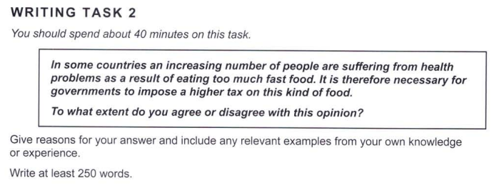

Essay Response:

The problem of obesity, and other health problems related with fast food, are expected to get worse in upcoming years if no actions are taken to curb them. This is a complex issue, and I do not believe that a higher tax on such food items would help in solving this issue. There are several reasons for this, but what are the major ones, and how do we ameliorate them?

In my experience, I have observed that people who consume a lot of fast-food fall into one of two categories: Either they are unable to afford healthier options, or they prefer the taste of these kinds of junk food, paying no heed to their health. Each of these groups of people must be considered separately, since we are looking for an all-round sustainable solution that takes care of our society’s well-being.

Firstly, consider those who are unable to afford fresh produce, resorting to the quick and cheap options that fast-food chains offer. Increasing taxes would cut off the only thing keeping them from food insecurity, and although the intent of this move is to push them to eat better, their lives would be at danger. Hence, to address this group, governments should find ways to subsidise fresh food items, especially for poorer communities. Only then, can a fast-food tax be remotely viable.

Secondly, what about people who eat it out of interest, with no economical constraints weighing them down? If economical constraints were not a reason for them to start consuming these foods, then it surely would not push them out of it. Hence, governments could introduce methods that are ‘softer’ than taxing these commodities, like, for instance, using informational advertisements, campaigns, or drives, to inform the public. Moreover, the major problem for these people is the lack of knowledge they have about the adverse effects of such food items, and making public announcements would mitigate this issue.

In conclusion, I mostly disagree with the given opinion, and believe that the methods listed above would be more useful in targeting the issue head-on.